
Business Question and Visualization Report

Date | 24 September 2026
Team ID | Desaisabiha1212@gmail com
Project Name
Maximum Marks | 5 Marks

Visualization development is the process of creating graphical representations of data tounderstand, analyze, and make decisions. In this project, Tableau is used to convert online food delivery survey data into visual formats such as bar charts and dashboards. These visualizations help to understand customer preferences, spending patterns, ordering habits, and food delivery trends.
Business Questions and Visualisation
The process involves defining specific business questions to create meaningful visualizations using data in Tableau. These questions help identify important customer preferences, ordering patterns, spending habits, and food delivery platforms. Tableau charts and dashboards are used to analyze the data and generate useful business insights.

Sample
- What is your age group?
  - Code-
COUNT([What is your age group?])
  - Screenshot of visualisation-
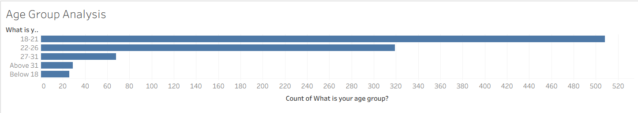
- How much do customers usually spend on a single food order?
  - Code-
COUNT([How much do you usually spend on a single food order?])
  - Screenshot of visualisation
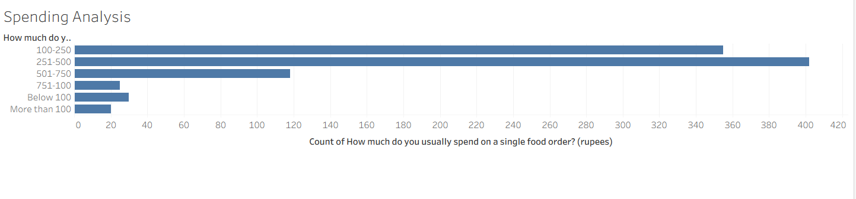
- What type of food do you order most frequently?
  - Code-
COUNT([What type of food do you order most frequently?])
  - Screenshot of visualisation
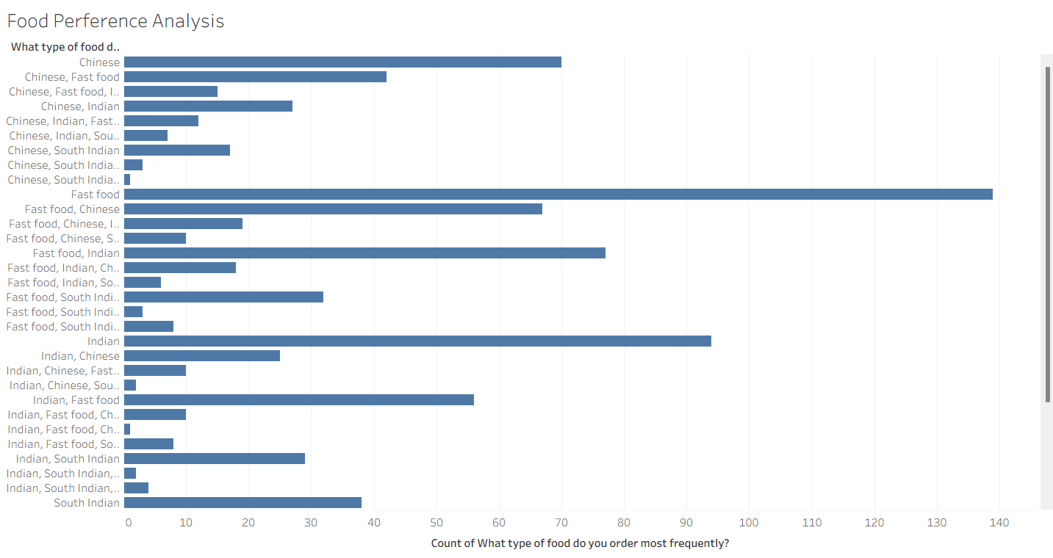
- Which food delivery platform do you use most often?
  - Code
COUNT([Which food delivery platform do you use most often?])
  - Screenshot of visualisation
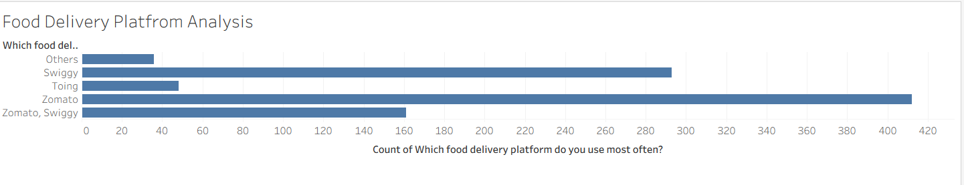
- What is your most common reason for ordering food online?
  - Code-
COUNT([What is your most common reason for ordering food online?])
  - Screenshot of visualisation
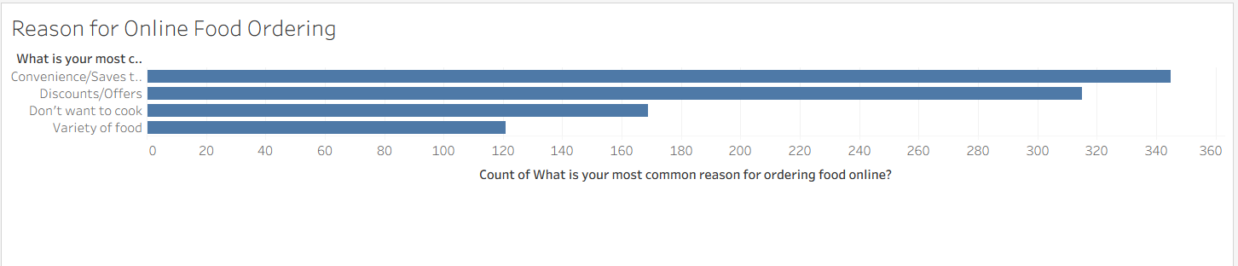
- Which factor is most important when choosing a restaurant?
  - Code-
COUNT([Which factor is most important when choosing a restaurant?])
  - Screenshot of visualisation
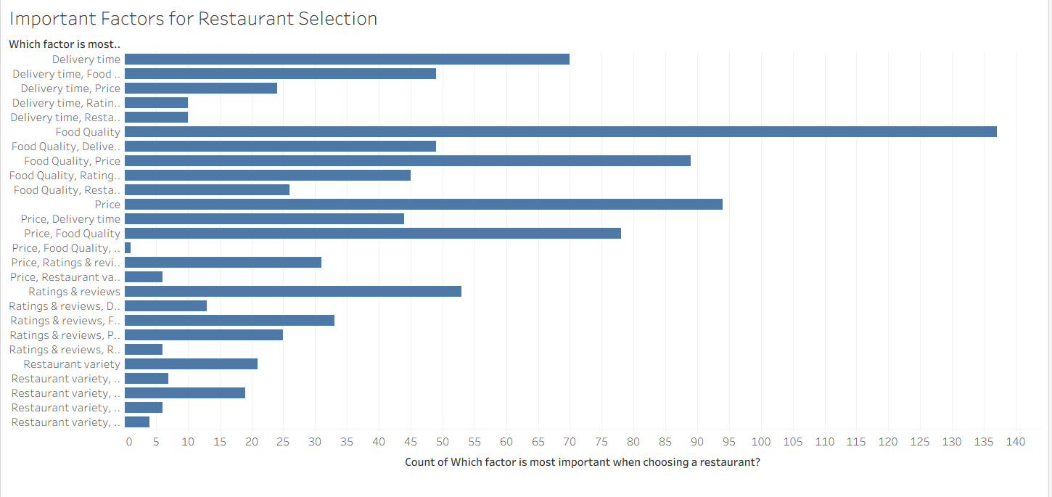
- What problem do you encounter most often with online food delivery?
  - Code-
COUNT([What problem do you encounter most often with online food delivery?])
  - Screenshot of visualisation
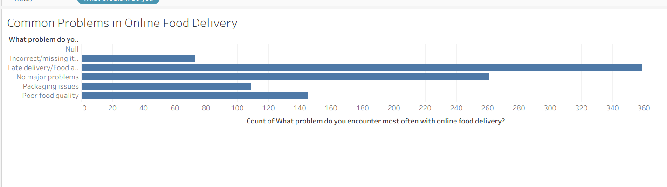
- How often do discounts and coupons, ratings and reviews influence your food choice and ordering decisions?
  - Code-
COUNT([How often do discounts or coupons or rating and review influence your food choice and to place an order])
  - Screenshot of visualisation
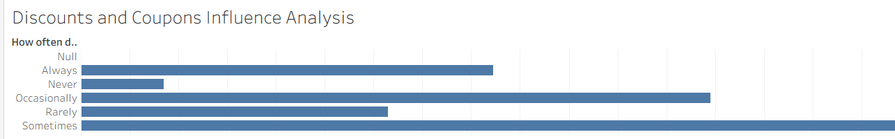

Note: Min 8 business question and visualisations Required inform of above

